**Coordinate System Definitions for DPRG Mobile Mapping Systems**

# **Coordinate System Definitions for the M600-UAV (Applanix) System**

$$Y_{v}$$

$$Z_{v}$$

$$X_{v}$$

**Up Direction**

**Down Direction**

**Vehicle Frame**

**Driving Direction**

**S1000 platform (plan-view)**

$$Z_{b}$$

$$Z_{LU}$$

$$Y_{c}$$

$$Y_{b}$$

$$X_{b}$$

$$X_{LU}$$

$$Y_{LU}$$

$$X_{c}$$

$$Z_{c}$$

**Camera (Sony)**

**LU (VLP16)**

**IMU (APX15)**

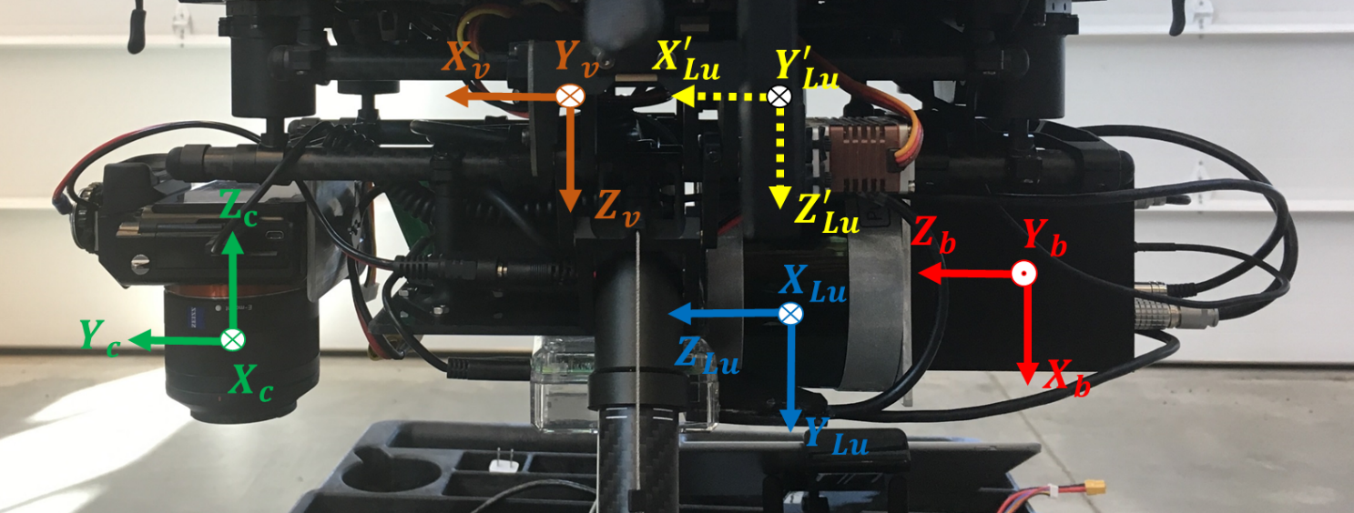

$$Y_{Lu}$$

$$Z_{Lu}$$

$$X_{Lu}$$

$$Z_{b}$$

$$X_{b}$$

$$Y_{b}$$

$$Y_{Lu}^{'}$$

$$Z_{Lu}^{'}$$

$$X_{Lu}^{'}$$

***IMPORTANT NOTES:***

1. *Processing software**is* **POSPac MMS**.
2. *The* ***Navigation (Mapping) frame*** *for the* ***Applanix IMUs*** *(APX-15, POS LV 220, POS LV 125) is set to****:*** North-East-Down (NED).
3. *We select the* ***Vehicle frame*** *to be* ***X*** (forward), **Y** (right) and **Z** (down) to be compatible with the mapping frame.
4. ***Transformation*** *from Laser unit to mapping frame is as follows:*

***For LiDAR UNIT:***

,

where:

* is the rotation from NED mapping frame to ENU mapping frame. It is applied in the PCAP reconstruction module if it recognizes that an Applanix unit is being used according to the flag in **config file**. The nominal value for this rotation is:

***Note:***  *denotes the rotation to be applied to ENU frame to make it parallel to NED frame*.

* is the rotation from vehicle to mapping frame. This rotation value is obtained from POSPac software after converting the body (IMU) frame measurements to vehicle frame measurements.
* In Applanix IMUs, we still need to define the rotation matrix $R_{b}^{v}$ to map all IMU measurements to NED frame. According to the current IMU fixation w.r.t. the vehicle (S1000+ in this case), the nominal values of the rotation components, which should be set in the POSPAC software to generate the BOP file in the mapping frame should be as follows:
$$R_{b}^{v}=R_{z}(180){ . R}_{y}(-90) . R_{x}(0)$$

$$Z_{v}^{''}≡Z_{b}$$

$$X_{v}$$

$$Z_{v}^{'}$$

$$Y_{v}^{'}$$

$$Y_{v}$$

$$Z_{v}$$

$$X_{v}^{'}$$

$$X_{v}^{''}≡X_{b}$$

$$Y_{v}^{''}≡Y_{b}$$

$$R_{z}(180)$$

$$R_{y}(-90)$$

* The rotation from the LiDAR unit to the vehicle frame and is obtained as one of the results from calibration. It represents the relative orientation between the LiDAR unit and the body frame, and is set initially as:
$${R_{LU}^{v}=R}_{x}(90) . R_{y}(90) . R_{z}(0)$$

$$X_{v}^{'}$$

$$Z_{v}^{'}$$

$$R_{x}(90)$$

$$Z_{v}$$

$$X_{v}$$

$$Y_{v}$$

$$Z_{v}^{''}≡Z_{lu}$$

$$Y_{v}^{'}$$

$$Y_{v}^{''}≡Y_{lu}$$

$$_NED$$

$$X_{v}^{''}≡X_{lu}$$

$$R_{y}(90)$$

* These values are automatically applied in the PCAP reconstruction (calibration) module if it recognizes that an Applanix unit is being used according to the flag in **config file**.
* To avoid the **Gimbal Lock** during the transformation from LU frame and vehicle (body) frame, a virtual frame is created as a transit between the two frames. So, the modified transformation from Laser unit to mapping frame is given as:
$$R_{LU}^{ENU}= {R_{NED}^{ENU} .R}_{v}^{NED} R_{LU^{'}}^{v}. R_{LU}^{LU^{'}}$$

* $R_{LU}^{LU^{'}}$ is the rotation from the $LU$ frame to the $LU^{'}$ frame. This is fed as input in PCAP module, and equals the $R_{LU}^{v}$ rotation value as shown above.
* $R_{LU^{'}}^{v}$ is a virtual rotation from $LU^{'}$ frame to the body frame, which are considered to be approximately parallel. This is included in the PCAP module.

$$R_{LU^{'}}^{v}=R_{x}(0){ . R}_{y}(0) . R_{z}(0)$$

***For Camera:***

$R_{c}^{ENU}= R_{NED}^{ENU} . R_{v}^{NED} . R_{c}^{v}$,

where:

* $R_{c}^{v}$ is the rotation from camera frame to vehicle frame (orientation mounting parameters). Currently, we have Sony alpha 7R camera fixed with the S1000+ looking down. This value of $R_{c}^{v}$ is also used as initial approximation in the calibration module and is set to the following value:

$$R_{c}^{v}= R_{x}(180) . R_{y}(0) . R_{z}(-90)$$

$$Y_{v}^{''}≡Y_{c}$$

$$X_{v}$$

$$X_{v}^{'}$$

$$X_{v}^{''}≡X_{c}$$

$$Z_{v}^{'}$$

$$Y_{v}^{'}$$

$$Z_{v}^{''}≡Z_{c}$$

$$_NED$$

$$R_{x}(180)$$

$$Z_{v}$$

$$Y_{v}$$

$$R_{Z}(-90)$$

1. **Coordinate System Definitions for the PhenoRover (Applanix) System**

$$Y_{v}$$

$$Z_{v}$$

$$X_{v}$$

**Driving Direction**

**Up Direction**

**Down Direction**

**Vehicle Frame**

**Camera (Flea2)**

$$Y_{c}$$

**Camera (Flea3)**

$$Y_{c}$$

**PhenoRover platform (Top-View)**

$$Y_{c}$$

$$Z_{c}$$

$$Z_{c}$$

$$X_{c}$$

$$X_{c}$$

$$X_{b}$$

$$Z_{LU}$$

$$Z_{LU}$$

$$Y_{b}$$

$$Z_{b}$$

**`**

**IMU (POS-LV 125)**

$$Y_{LU}$$

$$Y_{LU}$$

**LUleft (HDL32E)**

**LUright (HDL32E)**

$$X_{LU}$$

$$X_{LU}$$

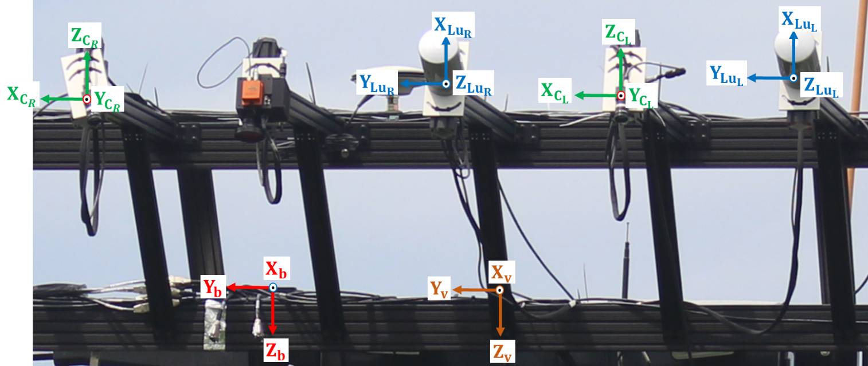

***IMPORTANT NOTES:***

1. *Processing software**is* **POSPac MMS**.
2. *The* ***Navigation (Mapping) frame*** *for the* ***Applanix IMUs*** *(APX-15, POS LV 220, POS LV 125) is set to****:*** *North-East-Down (NED).*
3. *We select the* ***Vehicle frame*** *to be* ***X*** (right), **Y** (forward) and **Z** (up) to be compatible with the mapping frame.
4. ***Transformation*** *from Laser unit to mapping frame is as follows:*

***For LiDAR UNIT:***

,

where:

* is the rotation from NED mapping frame to ENU mapping frame. It is applied in the PCAP reconstruction module if it recognizes that an Applanix unit is being used according to the flag in **config file**. The nominal value for this rotation is:

***Note:***  *denotes the rotation to be applied to ENU frame to make it parallel to NED frame*.

* is the rotation from vehicle to mapping frame. This rotation value is obtained from POSPac software after converting the body (IMU) frame measurements to vehicle frame measurements.
* In Applanix IMUs, we still need to define the rotation matrix $R_{b}^{v}$ to map all IMU measurements to NED frame. According to the current IMU fixation w.r.t. the vehicle (PhenoRover in this case), the nominal values of the rotation components, which should be set in the POSPAC software to generate the BOP file in the mapping frame should be as follows
$$R_{b}^{v}=R_{z}(0){ . R}_{x}(0) . R_{y}(0)$$

$$X_{v}$$

$$X_{b}$$

$$Z_{b}$$

$$Y_{b}$$

$$Y_{v}$$

$$Z_{v}$$

* $R_{LU}^{v}$ is the rotation from the LiDAR unit to the vehicle frame and is obtained as one of the results from calibration. It represents the relative orientation between the LiDAR unit and the body frame, and is set initially as:
$${R_{LU}^{v}=R}_{x}(0) . R_{y}(105) . R_{z}(0)$$

$${\begin{aligned}Z_{v}^{'}≡Z_{lu} \\ \end{aligned}}_{v}$$

$$X_{v}$$

$${\begin{aligned}X_{v}^{'}≡X_{lu} \\ \end{aligned}}_{v}$$

$${\begin{aligned}Y_{v}^{'}≡Y_{lu} \\ \end{aligned}}_{v}$$

$$Z_{v}$$

$$Y_{v}$$

$$R_{y}(105)$$

* To avoid the **Gimbal Lock** during the transformation from LU frame and vehicle (body) frame, a virtual frame is created as a transit between the two frames. So, the modified transformation from Laser unit to mapping frame is given as:
$$R_{LU}^{ENU}= {R_{NED}^{ENU} .R}_{v}^{NED} R_{LU^{'}}^{v}. R_{LU}^{LU^{'}}$$

* $R_{LU}^{LU^{'}}$ is the rotation from the $LU$ frame to the $LU^{'}$ frame. This is fed as input in PCAP module, and its value is:
$$R_{Lu}^{Lu^{'}}=R_{x}(90) . R_{y}(90) . R_{z}(0)$$

* $R_{LU^{'}}^{v}$ is a virtual rotation from $LU^{'}$ frame to the body frame, which is obtained from calibration. This is included in the PCAP module.

$$R_{LU^{'}}^{v}=R_{x}(-90){ . R}_{y}(0) . R_{z}(15)$$

***For Camera UNIT:***

$R_{c}^{ENU}= R_{NED}^{ENU} . R_{v}^{NED} . R_{c}^{v}$,

where:

* $R_{c}^{v}$ is the rotation from camera frame to vehicle frame (orientation mounting parameters). Currently, we have two Flea 2 cameras fixed with the PhenoRover looking down. This value of $R_{c}^{v}$ is also used as initial approximation in the calibration module and is set to the following value:

$$R_{c}^{v}= R_{x}(180) . R_{y}(0) . R_{z}(-90)$$

$$Y_{v}^{''}≡Y_{c}$$

$$X_{v}$$

$$X_{v}^{'}$$

$$X_{v}^{''}≡X_{c}$$

$$Z_{v}^{'}$$

$$Y_{v}^{'}$$

$$Z_{v}^{''}≡Z_{c}$$

$$_NED$$

$$R_{x}(180)$$

$$Z_{v}$$

$$Y_{v}$$

$$R_{Z}(-90)$$

**Results of Calibration:**

The mounting parameters for the slave sensor are in the virtual LiDAR unit frame and they need to be transformed by the Rotation Matrix from virtual LiDAR unit frame to the LiDAR unit frame.

$$R_{Right^{'}}^{Left^{'}}=R_{x}(-1.1719){ . R}_{y}(0.2968) . R_{z}(6.2679)$$

$$r_{Right^{'}}^{Left^{'}}=[-0.0047; 0.0181; 0.7564]$$

Virtual Left and Right LiDAR unit coordinate frames:

$$R_{Lu}^{Lu^{'}}=R_{x}(90) . R_{y}(90) . R_{z}(0)$$

$$R_{Lu^{'}}^{Lu}=R_{x}(-90) . R_{y}(0) . R_{z}(-90)$$

$$Z_{Lu}$$

**Transformation to get $R_{Right}^{Left}$ and $r_{Right}^{Left}$ from $R_{Right^{'}}^{Left^{'}}$ and $r_{Right^{'}}^{Left^{'}}$:**

$$X_{Lu}^{''}≡X_{Lu^{'}}$$

$$R_{z}(-90)$$

$$Y_{Lu}^{'}$$

$$R_{x}(-90)$$

$$X_{Lu}$$

$$Y_{Lu}$$

$$r_{Right}^{Left}=R_{Left^{'}}^{Left} r_{Right^{'}}^{Left^{'}}$$

$$R_{Right}^{Left}=R_{Left^{'}}^{Left} R_{Right^{'}}^{Left^{'}} R_{Right}^{Right^{'}}$$

$R_{Left^{'}}^{Left}$ and $R_{Right}^{Right^{'}}$ are fixed rotations. $r_{Right^{'}}^{Left^{'}}$ and $R_{Right^{'}}^{Left^{'}}$ are obtained from calibration.

**Results:**

$$r_{Right}^{Left}=\left[0.0181, 0.7564, -0.0047\right]$$

$$R_{Right}^{Left}=Rotation(0.4255, 6.2605, -1.1789)$$

# **Coordinate System Definitions for the Car-mount (Novatel) System**

$$X_{v}$$

$$Z_{v}$$

$$Y_{v}$$

**Up Direction**

**Down Direction**

**Vehicle Frame**

**Driving Direction**

$$Z_{c}$$

$$X_{c}$$

$$Y_{c}$$

**Camera (Flea2)**

**Car mount platform (Top-View)**

$$Y_{c}$$

$$X_{LU}$$

$$Y_{LU}$$

$$Z_{LU}$$

**`**

**LUleft (HDL32E)**

**LUright (HDL32E)**

$$X_{LU}$$

$$Y_{LU}$$

$$Z_{LU}$$

**IMU (CPT)**

$$X_{b}$$

$$Y_{b}$$

$$Z_{b}$$

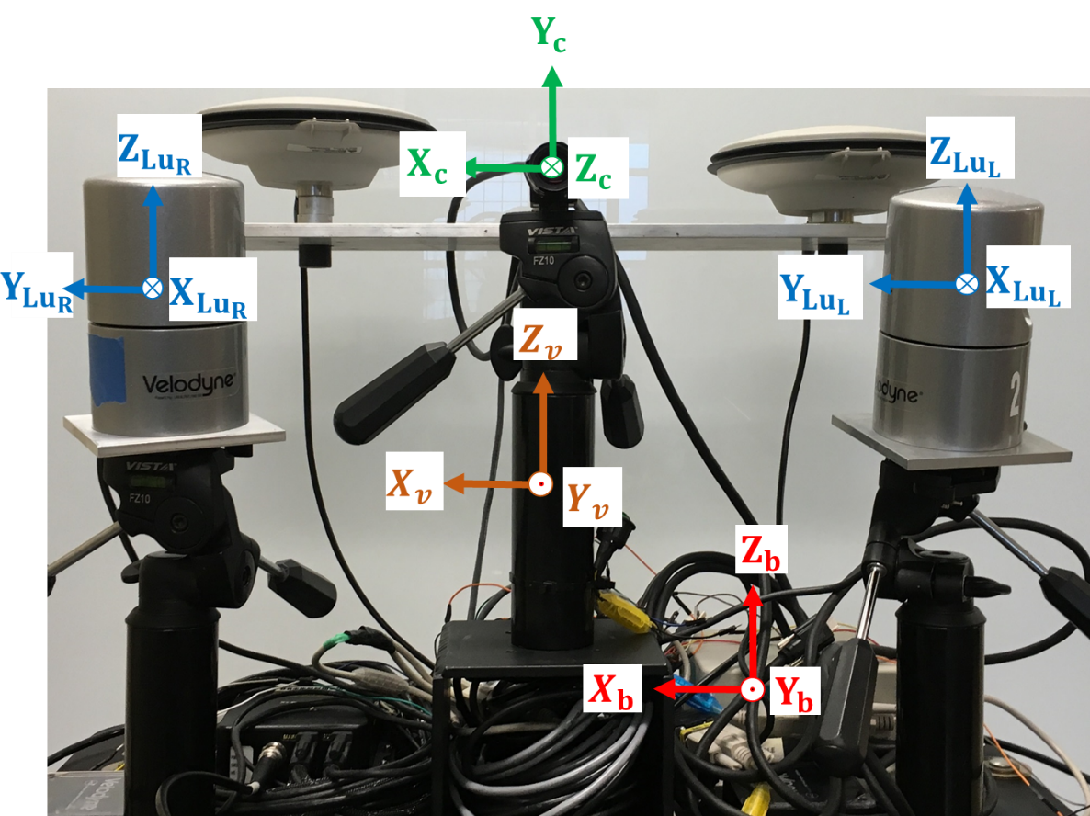

***IMPORTANT NOTES:***

1. *Processing software**is* **Inertial Explorer**.
2. *The* ***Navigation (Mapping) frame*** *for the* ***Novatel IMUs (CPT and IGM)*** *is set to****:*** East-North-Up (ENU).
3. *We select the* ***Vehicle frame*** *to be* ***X*** (right), **Y** (forward) and **Z** (up) to be compatible with the mapping frame.
4. ***Transformation*** *from Laser unit to mapping frame is as follows:*

***For LiDAR UNIT:***

$R_{LU}^{ENU}= R_{v}^{ENU} . R_{LU}^{v}$,

where:

* $R_{v}^{ENU}$ is the rotation from vehicle to mapping frame. This rotation is obtained from Inertial Explorer software after converting the body (IMU) frame measurements to vehicle frame measurements.
* In Inertial Explorer, we still need to define the rotation matrix $R_{b}^{v}$ to map all IMU measurements to vehicle frame. According to the current IMU fixation w.r.t. the vehicle (Car-Mount in this case), there is no relative rotation between the IMU and the vehicle frame. This implies that the nominal values of the rotation components, which should be set in the Inertial Explorer software to generate the BOP file in the mapping frame should be as follows:
$$R_{b}^{v}=R_{z}(0){ . R}_{x}(0) . R_{y}(0)$$

$$Z_{b}$$

$$Y_{b}$$

$$X_{b}$$

$$Y_{v}$$

$$X_{v}$$

$$Z_{v}$$

* $R_{LU}^{v}$ is the rotation from the LiDAR unit to the vehicle frame and is obtained as one of the results from calibration. It represents the relative orientation between the LiDAR unit and the body frame, and is set initially as:
$${R_{LU}^{v}=R}_{x}(-5) . R_{y}(0) . R_{z}(-65)$$

$${\begin{aligned}Z_{v}^{''}≡Z_{lu} \\ \end{aligned}}_{v}$$

$${\begin{aligned}Y_{v}^{''}≡Y_{lu} \\ \end{aligned}}_{}$$

$${\begin{aligned}Y_{v}^{'} \\ \end{aligned}}_{v}$$

$$Y_{v}$$

$${\begin{aligned}Z_{v}^{'} \\ \end{aligned}}_{v}$$

$${\begin{aligned}X_{v}^{'} \\ \end{aligned}}_{v}$$

$$Z_{v}$$

$$X_{v}$$

$${\begin{aligned}X_{v}^{''}≡X_{lu} \\ \end{aligned}}_{v}$$

$$R_{z}(-65)$$

$$R_{x}(-5)$$

* Unlike the coordinate transformation for UAV (using Applanix IMU’s, which operate in the NED frame), we do not need a virtual frame to avoid gimbal lock while using Novatel units (ENU frame). So, the transformation from Laser unit to mapping frame is given as:

$$R_{LU}^{ENU}= R_{v}^{ENU} . R_{LU}^{v}$$

***For Camera UNIT:***

$R_{c}^{ENU}= R_{v}^{ENU} . R_{c}^{v}$,

where:

* $R_{c}^{v}$ is the rotation from camera frame to vehicle frame (orientation mounting parameters). Currently, we have two cameras fixed on the Car-Mount platform: Flea-2 camera looking forward and Flea-3 camera looking to the right w.r.t. moving direction of the platform. The values of $R_{c}^{v}$ corresponding to each camera are also used as initial approximations in the calibration module and are set to the following values:

***FLEA-2 CAMERA:***

$$R_{c}^{v}= R_{x}(90) . R_{y}(0) . R_{z}(0)$$

$${X'}_{v}≡X_{c}$$

$${Y'}_{v}≡Y_{c}$$

$$Y_{v}$$

$${Z'}_{v}≡Z_{c}$$

$$Z_{v}$$

$$X_{v}$$

$$R_{x}(90)$$

# **Coordinate System Definitions for the UAV- Applanix System and Nano - SWIR Camera**

$$Y_{v}$$

$$Z_{v}$$

$$X_{v}$$

**Up Direction**

**Down Direction**

**Vehicle Frame**

**Flight Direction**

$$X_{N}$$

$$Y_{N}$$

$$Z_{N}$$

$$Y_{S}$$

$$X_{S}$$

**Camera (SWIR)**

$$Z_{S}$$

$$X_{b}$$

$$Z_{b}$$

**S1000 platform (plan-view)**

$$Y_{b}$$

**IMU (APX15)**

**Camera (Nano)**

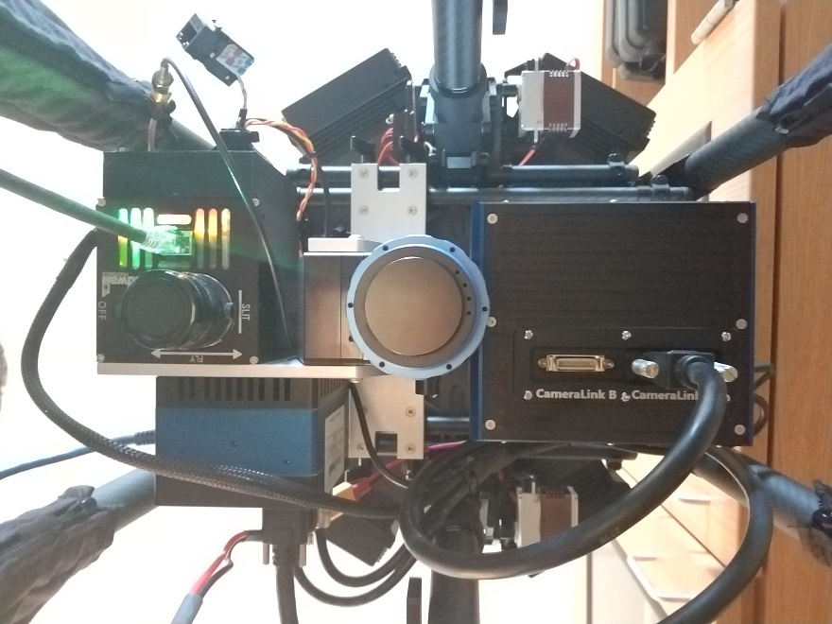

$$Y_{V}$$

$$X_{V}$$

$$X_{N}$$

$$Y_{S}$$

$$Z_{V}$$

$$Z_{N}$$

$$Z_{S}$$

$$X_{S}$$

**Flight Direction**

$$Y_{N}$$

$$Z_{b}$$

$$X_{b}$$

$$Y_{b}$$

***IMPORTANT NOTES:***

1. *Processing software**is* **POSPac MMS**.
2. *Two rotation matrix derived based on the manual*.
   1. *IMU w*.r.t. reference (Vehicle) -> ((brings IMU to Vehicle))

Order: Z 🡪 Y 🡪 X

* 1. SWIR w.r.t UAV -> ((brings SWIR to Vehicle))

Order: Z 🡪 Y 🡪 X

* 1. Nano w.r.t UAV -> ((brings Nano to UAV))

Order: Z 🡪 Y 🡪 X

${R_{n}^{v}=R}_{Z}\left(-180\right)$

$$Z_{n}$$

$$X_{n}^{'}≡X_{b}$$

$$_NED$$

$$X_{n}^{'}≡X_{b}$$

$$_NED$$

$$Y_{n}$$

$$X_{n}$$

$$Z_{n}^{'}≡Z_{b}$$

$$_NED$$

$$Y_{n}^{'}≡Y_{b}$$

$$_NED$$

$$R_{z}(-180)$$